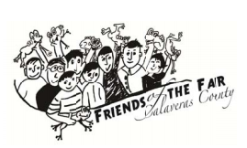
FRIENDS OF THE FAIR
AGENDA
June 17th 2020
6:00pm

- CALL TO ORDER

- ROLL CALL OF BOARD MEMBERS

- APPROVAL OF MINUTES – April 15th, 2020

- TREASURER’S REPORT

- CORRESPONDENCE

- COMMITTEE REPORTS
  - JR. LIVESTOCK – SHAWN WESTBERG
  - ALCOHOL/EVENTS – FIRMAN BROWN
  - WHISKERINO – ISABEL MONCADA
  - MEMBERSHIP – DONA/SARAH
  - POT O’GOLD RAFFLE – ROB MILLER
  - DERBY CAR – JEFF HUGHES
  - CEO – LAURIE GIANNINI
  - CATTLEMAN’S PARK IMPROVEMENTS – JERRI/ROB
  - BUDGET COMMITTEE – DONA/RAELYN/JEFF

- UNFINISHED BUSINESS – Derby Car sponsorship for October’s Hometown Hoedown.

- NEW BUSINESS –

- DIRECTORS COMMENTS -

ADJOURN MEETING – The next regularly scheduled meeting will be Wednesday, July 15th 2020 @ 6:00pm at the Ranch House Meeting Room

